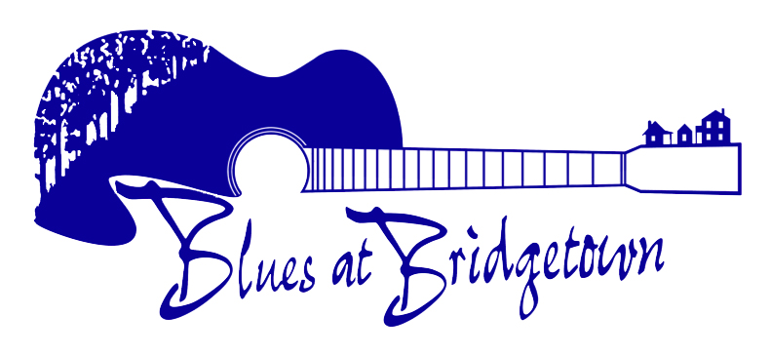 | 2024  FESTIVAL ARTIST  APPLICATION FORM

Fields marked * are required.

CONTACT DETAILS

Contact Full Name* | Click or tap here to enter text.

Postal Address* | Click or tap here to enter text.

Email Address* | Click or tap here to enter text.

Day Phone Number* | Click or tap here to enter text. | Mobile* | Click or tap here to enter text.

ARTIST/GROUP DETAILS

Name of Artist/Group* | Click or tap here to enter text.

No. of people in Group* | Click or tap here to enter text. | Website | Click or tap here to enter text.

Description* Brief description of the act. Include music style/genre, whether performing original music and/or covers and any other Festivals you have performed at.

Click or tap here to enter text.

Musicians* Please supply the name of each person and their role i.e. Fred Smith, lead vocalist.

Click or tap here to enter text.

Online Music & Performances Please supply details/links to any FREE online music of performances i.e. SoundCloud, ReverbNation, Youtube, Vimeo etc. If you have some on your website please state that.
NOTE: these need to be accessible without payment/purchase of tracks.

Click or tap here to enter text.

FEE REQUEST & AVAILABILITY

Please nominate your required fee which must include travel. Most performers stay for the duration of the Festival. Most appearances are between 1 –1½ hrs however, some performance times maybe up to 3 hours. Please supply your fee and the total duration for a minimum of two shows.

2 SHOWS* | Fee (ex GST)* | $Click or tap here to enter text. | Total Duration* | Click or tap here to enter text.

3 SHOWS | Fee (ex GST)* | $Click or tap here to enter text. | Total Duration* | Click or tap here to enter text.

AVAILABILITY* | tick if available | Fri 08 Nov, 2024 | ☐ | Sat 09 Nov, 2024* | ☐ | Sun 10 Nov, 2024* | ☐

ACCOMODATION

All accommodation arrangements will be negotiated with successful applicants after the next step of the Festival programming process in either: Hotel, Motel, B&B, Chalet or Camp Sites. As we are a not for profit organisation ONLY performing artists/musicians performing on stage will be accommodated.

Will you require accommodation?* | Yes | ☐ | No | ☐

IMPORTANT INFORMATION

• TICKETS/PASSES: Artists who are registered to perform at the 2024 Festival will receive a backstage pass per artist/musician when they check in. Any partner(s)/spouse(s) or associated person not part of the performance may be eligible to purchase an Artist Discount Ticket.
• APPLICATIONS: Applications close 30 April 2024. For your application to be considered it must fully completed.

TERMS & CONDITIONS

I am the principal contact of the artist/group and have the permission to represent the artist/ group in all dealings with the Blues at Bridgetown Inc. I shall inform the Blues at Bridgetown Inc. of any changes to this arrangement.

I will receive all correspondence and forward all information onto the other members of my group.

I will faithfully supply all required information, in full, by dates requested by Blues at Bridgetown Inc.

I acknowledge that this application does not guarantee selection and that if selected, the Festival programmers have the sole right to determine the act’s performance date and times(s) (within the specified availability).

☐ | I have read, understood and agree to the Terms & Conditions* please tick to confirm

Signature: Click or tap here to enter text.

Name: Click or tap here to enter text.

Date: Click or tap here to enter text.

FESTIVAL ARTIST – APPLICATION GUIDE

FESTIVAL DETAILS

Dates: 5pm Friday, 08 November 2024 – 10pm Sunday 10 November, 2024
Location: Bridgetown, Western Australia

YOUR APPLICATION

Blues at Bridgetown Festival artists will be selected based on the information supplied with your application. Please ensure that you have completed the application fully and provided/attached all the necessary items.

A checklist follows to assist you to complete the application fully.

Due to the large number of applications, any application not completed in full with all required information by the final date of submission (April 30 2024) will not be considered.

Good Luck!

APPLICATION CHECKLIST

Your application will only be considered if it is accompanied by all required documentation and fully completed. Use this checklist to ensure you are submitting your application correctly.

☐ | Entire application form is fully completed.

☐ | You have acknowledged the Terms and Conditions, signed and dated the application.

☐ | A quality digital artist/band jpg photo of a minimum of 300 dpi has been provided

☐ | Links to your music have been supplied and/or mp3(s) have been provided

SUBMITTING YOUR APPLICATION

Emailing your application is the preferred method, with the required digital images and music attached in a single completed application. i.e. do not send through multiple emails with different parts/elements of your application in different emails.

Email: Kelsie@bluesatbridgetown.com.au and artists@bluesatbridgetown.com.au

If you are unable to email your application, you can also post your application. In this case, your digital photo and music should be supplied on a CD or USB stick.

Post: PO Box 206
Bridgetown WA 6255

